CUSTOMER SHOPPING BEHAVIOR ANALYSIS
- Project Overview
This project analyzes customer shopping behavior using transactional data from 3,900 purchases across various product categories. The goal is to uncover insights into spending patterns, customer segments, product performances, and subscription behavior to guide strategic business decisions.
- Dataset Summary
    - Rows: 3,900
    - Columns: 18
    - Kea Features:
- Customer demographics (Age, Gender, Local, Subscription Status).
- Purchase details (Item Purchased, Category, Purchase Amount, Season, Size, Color).
- Shopping behavior (Discount Applied, Promo Code, Previous Purchases, Frequency of Purchases, Review Rating, Shopping Type).
    - Missing Data: 37 values in Review Rating column.

- Exploratory Data Analysis using Python
We begin with data preprocessing and cleaning in Python:
  - Data Loading: Import the dataset using pandas.
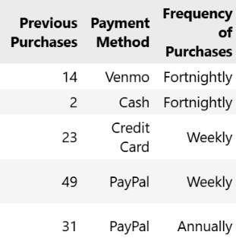
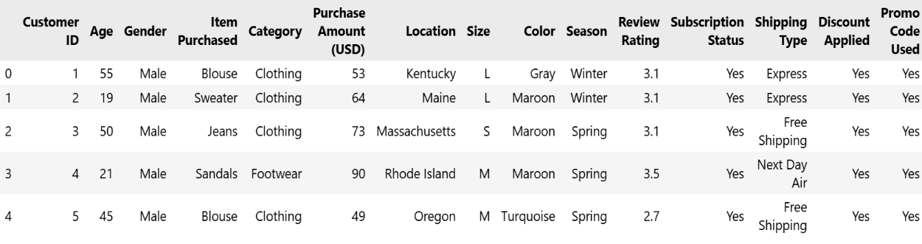
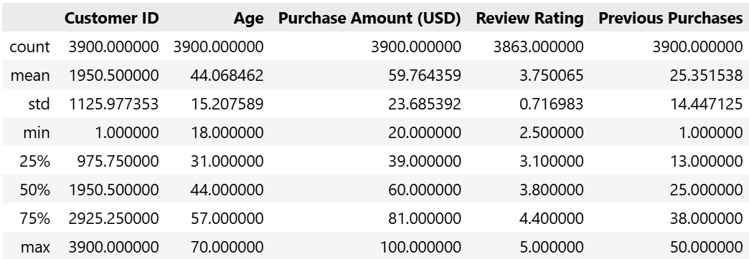
  - Initial Exploration: Using .info() to check structure and .describe() for summary statistics.

  - Missing Data Handling: Checked for null values and imputed missing values in the ‘Review Ring’ column using the median rating of each product category.
  - Column Standardization: Rename columns to snake case for better readability and documentation.
  - Feature Engineering:
- Created “age_group” column by binning “age” column.
- Converted “purchase_frequency” column into numerical.
  - Data Consistency Check: Verified if “discount_applied” and “promo_code_used” were redundant , dropped “promo_code_used”.
  - Database Integration: Connecting Python script to PostgreSQL and loading the cleaned DataFrame into the database for SQL analysis.

- Data Analysis using SQL:
We performed structured analysis in PostgreSQL to answer key business questions.
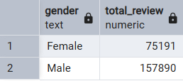
            - Revenue by Gender:
Compared total revenue generated by male Vs female customers.

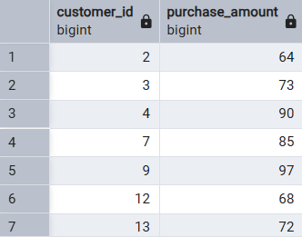
            - More expenditure using discount:
Customer used a discount but still spent more than average purchase amount.

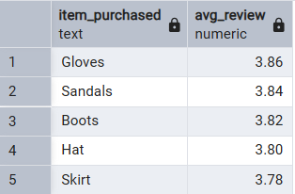
            - High Review Rating:
The top 5 products with the highest average review rating.

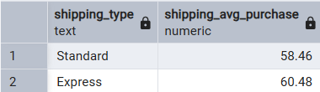
            - Revenue Between Standard Vs Express shipping:
The average purchase amount between standard and express shipping.

            - Revenue comparison between Subscribed Vs Unsubscribed:
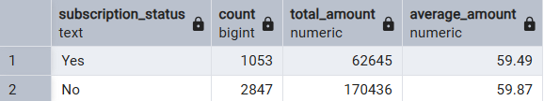
Average spend and total revenue between Subscribed and Unsubscribed.

            - Highest Percentage of Discount:
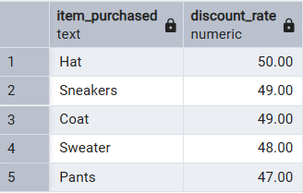
The top 5 products have the highest percentage of purchases with discount applied.

            - Segmentation of Customers:
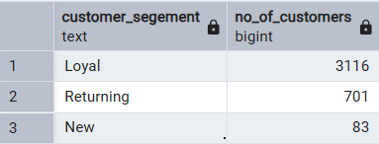
Segment Customers into New, Returning and Loyal based on there previous purchases.

            - Categories Top Purchase:
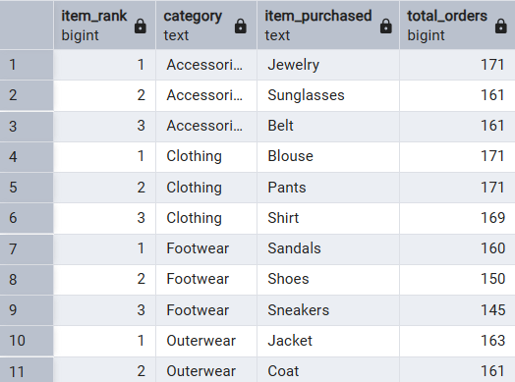
The top 3 most purchased products within each category.

            - Likely to Subscribe:
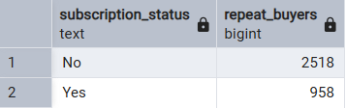
Customers who are repeat buyers (more than 5 previous purchases) also likely to subscribe.

            - Revenue By Age Group:
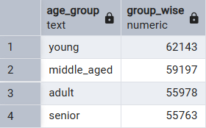
The revenue contributions of each age group.

- Dashboard in Power BI:
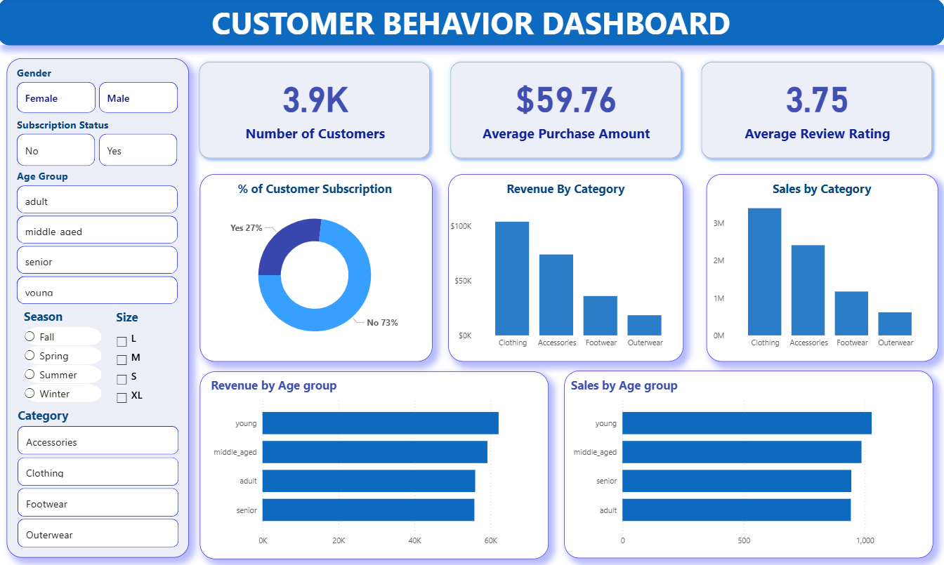
Finally, we built an interactive dashboard in Power BI to present insights visually.

- Business Recommendations
- Boost Subscriptions: Promote exclusive benefits for subscribers.
- Customer Loyalty Programs: Reward repeat buyers to move them into the “Loyal” segment.
- Review Discount Policy: Balance sales boosts with margin control.
- Product Positioning: Highlight top-rated and best-selling products in campaigns.
- Targeted Marketing: Focus efforts on high age groups and express-shipping users.

